**PURCHASE AND SALE AGREEMENT**

**BY AND BETWEEN**

**DESIGNED DESIGN ASSOCIATES - MIDVIEW CITY SINGAPORE**

Represented by: **ARLINGTON GENERAL TRADING LLC - DUBAI UAE**

**AND**

**SERAY GENERAL TRADING CHINA - JIANGSU CHINA**

Represented by: **SERAY FURNITURE TRADING LLC - DUBAI UAE**

THIS PURCHASE AND SALE AGREEMENT is entered into this 27TH day of January 2018, by and between **DESIGNED DESIGN ASSOCIATES - MIDVIEW CITY SINGAPORE** represented by **ARLINGTON GENERAL TRADING LLC - DUBAI UAE** (hereinafter referred as "Buyer") with office address at the United Arab Emirates and **SERAY GENERAL TRADING CHINA - JIANGSU CHINA** represented by **SERAY FURNITURE TRADING LLC - DUBAI UAE** (hereinafter referred as "Seller”) with office address at Dubai, United Arab Emirates.

**RECITALS:**

**WHEREAS,** the **SERAY GENERAL TRADING CHINA - JIANGSU CHINA** represented by **SERAY FURNITURE TRADING LLC - DUBAI UAE and DESIGNED DESIGN ASSOCIATES - MIDVIEW CITY SINGAPORE represented ARLINGTON GENERAL TRADING LLC - DUBAI UAE** can enter into this Sale and Purchase Agreement and sign pertinent documents with full rights under terms and conditions specified therein;

**WHEREAS,** the **SERAY GENERAL TRADING CHINA - JIANGSU CHINA** desires to sell the Products defined below and the **DESIGNED DESIGN ASSOCIATES - MIDVIEW CITY SINGAPORE** desires to purchase the Products from **SERAY GENERAL TRADING CHINA - JIANGSU CHINA.**

**NOW THEREFORE**, in consideration of the mutual covenants and the agreements herein contained and other goods and valuable (the receipt and sufficiency of which are hereby acknowledged) the parties agree as follows:

1. **Sale of Product**. **SERAY GENERAL TRADING CHINA - JIANGSU CHINA** hereby sells to **DESIGNED DESIGN ASSOCIATES - MIDVIEW CITY SINGAPORE** and **DESIGNED DESIGN ASSOCIATES - MIDVIEW CITY SINGAPORE** hereby purchases from **SERAY GENERAL TRADING CHINA - JIANGSU CHINA** the product details below:

|  |  |  |  |  |
| --- | --- | --- | --- | --- |
| **Description** | **Quantity** | **Unit** | **Unit Price** | **Amount** |
| Serjolly corner set 300x200 | 350 | SETS | AED 3,714.29 | AED 1,300,000.00 |

1. **Purchase Price**.  **DESIGNED DESIGN ASSOCIATES - MIDVIEW CITY SINGAPORE** shall pay to **SERAY GENERAL TRADING CHINA - JIANGSU CHINA** for the Products and for all obligations specified herein, as full and complete consideration therefore, the sum of **AED 1,300,000.00** (One Million Three Hundred Thousand Dirhams Only).
2. **Payment**. Payment of the Purchase Price shall be made by **DESIGNED DESIGN ASSOCIATES - MIDVIEW CITY SINGAPORE** or its representative **ARLINGTON GENERAL TRADING LLC - DUBAI UAE** to **SERAY GENERAL TRADING CHINA - JIANGSU CHINA** or its representative **SERAY FURNITURE TRADING LLC - DUBAI UAE** in full payment in advance before the delivery date.
3. **Acceptance**. “Acceptance" of the Product shall be deemed to occur on the date when, in the reasonable opinion of **DESIGNED DESIGN ASSOCIATES - MIDVIEW CITY SINGAPORE** the Product conforms to the Specifications, and has continuously operated in compliance with the Specifications for thirty (30) days after Product Turnover
4. **Indemnification.** In the event either party breaches or is deemed to have breached any of the representations and warranties contained in this Agreement, or fails to perform or comply with any of the covenants and agreements set forth in this Agreement, it shall hold harmless, indemnify and defend the other party, and its directors, officers, shareholders, attorneys, representatives and agents, from and against any damages incurred by the non-defaulting party.
5. **General.** **SERAY GENERAL TRADING CHINA - JIANGSU CHINA** shall perform this Agreement in compliance with all applicable local laws, rules, regulations, and ordinances, and represents that it shall have obtained all licenses and permits required by law to engage in the activities necessary to perform its obligations under this Agreement.

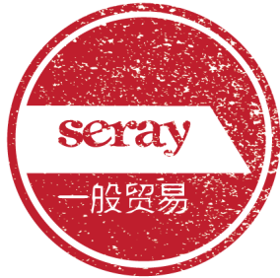

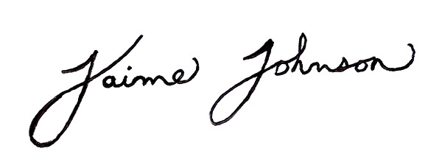

**___________________________________________**

**SERAY GENERAL TRADING CHINA - JIANGSU CHINA**

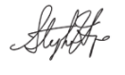

_____________________________________

**DESIGNED DESIGN ASSOCIATES - MIDVIEW CITY SINGAPORE**